Name | DIGVIJAY KUMAR THAKUR
Regd. Number | 12003378
Roll Number | 34
Section | KM005
Project Title | E-commerce Website


TABLE OF CONTENTS

S. No | NAME OF CONTENTS | PAGE NO
1. | INTRODUCTION TO PROJECT | 2 - 4
2. | DETAILS OF PROJECT | 5 - 9
3. | GITHUB LINK | 13
4. | LEARNING FROM THE PROJECT | 14

Github Link
https://github.com/psycho-codr/int220

Introduction
Computer plays an important role in our daily life. Anything we want we can get only in one mouse click. Speed, reliability and accuracy of the computer make it a powerful tool for different purposes. A very important and basic need of today’s modern business world is the quick availability and processing of information using computer. One can easily get the type of required information within a fraction of a second. The project that I have taken is also in this category which is used in our daily life whenever we want to purchase some items we can easily get them at our home.
E-commerce (electronic commerce) is the buying and selling of goods and services, or the transmitting of funds or data, over an electronic network, primarily the internet. These business transactions occur either as business-to-business (B2B), business-to-consumer (B2C), consumerto-consumer or consumer-to-business. The terms e-commerce and e-business are often used interchangeably. The term e-tail is also sometimes used in reference to the transactional processes for online shopping.

1.2 Objective
Developing a GUI based automated system, which will cover all the information Related to the all products which is used in our daily life. For example – Mobiles Phones, Laptops, Clothes, Books, Electronic Items and many more. So by this GUI based automated system a user want to purchase something then it only a mouse click away to purchase these products.
The e-commerce is mainly useful for ho haven’t time to go shopping or for comfortably to the customers. Those are just entered into this website and bought they want at any time they can visit the web-site. Customer will choose different items like mobile, laptops, etc. This website is based on this formal. After chosen items they pay bill thorough pay pal process. Customer will get their items just sitting at home.

1.3 Needs of Ecommerce
The “Ecommerce” is developed according the current need in different Fields. This is Ecommerce Website which provides facility for purchasing Mobiles, Laptops, tabs and many more items. So by using this system users which want to purchase some products will first Register an account on this portal then Login through their Username and Password, and then Select items which they want to purchase and add them to cart and finally checkout by giving payment details.
So by using this portal users can easily purchase products from their home.

Methodology Development Model

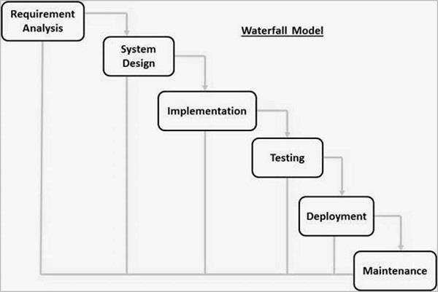

The sequential phases in Waterfall model are −
Requirement Gathering and analysis − All possible requirements of the system to be developed are captured in this phase and documented in a requirement specification document.
- System Design − The requirement specifications from first phase are studied in this phase and the system design is prepared. This system design helps in specifying hardware and system requirements and helps in defining the overall system architecture.
- Implementation − With inputs from the system design, the system is first developed in small programs called units, which are integrated in the next phase. Each unit is developed and tested for its functionality, which is referred to as Unit Testing.
- Integration and Testing − All the units developed in the implementation phase are integrated into a system after testing of each unit. Post integration the entire system is tested for any faults and failures.
- Deployment of system − Once the functional and non-functional testing is done; the product is deployed in the customer environment or released into the market.
- Maintenance − There are some issues which come up in the client environment. To fix those issues, patches are released. Also to enhance the product some better versions are released.
Maintenance is done to deliver these changes in the customer environment.

1.5 Tools and Technique
- Php
- Xampp
- Mysql yog
- HTML
- Bootstrap
- Sublime text
- Git hub
- Java Script
- Css
Php
Hypertext Preprocessor (or simply PHP) is a server-side scripting language designed for Web development, but also used as a general-purpose programming language. It was originally created by Rasmus Lerdorf in 1994,] the PHP reference implementation is now produced by The PHP Group. PHP originally stood for Personal Home Page,] but it now stands for the recursive acronym PHP: Hypertext Preprocessor.
PHP code may be embedded into HTML code, or it can be used in combination with various web template systems, web content management systems, and web frameworks. PHP code is usually processed by a PHP interpreter implemented as a module in the web server or as a Common Gateway Interface (CGI) executable. The web server combines the results of the interpreted and executed PHP code, which may be any type of data, including images, with the generated web page. PHP code may also be executed with a command-line interface (CLI) and can be used to implement standalone graphical applications.

Xampp
XAMPP is a free and open source cross-platform web server solution stack package developed by Apache Friends, consisting mainly of the Apache HTTP Server, MariaDB database, and interpreters for scripts written in the PHP and Perl programming languages. XAMPP stands for Cross-Platform (X), Apache (A), MariaDB (M), PHP (P) and Perl (P). It is a simple, lightweight Apache distribution that makes it extremely easy for developers to create a local web server for testing and deployment purposes. Everything needed to set up a web server – server application (Apache), database (MariaDB), and scripting language (PHP) – is included in an extractable file. XAMPP is also cross-platform, which means it works equally well on Linux, Mac and Windows. Since most actual web server deployments use the same components as XAMPP, it makes transitioning from a local test server to a live server extremely easy as well.

Mysql
MySQL Workbench is a unified visual tool for database architects, developers, and DBAs. MySQL Workbench provides data modeling, SQL development, and comprehensive administration tools for server configuration, user administration, backup, and much more. MySQL Workbench is available on Windows, Linux and Mac OS X.

HTML
Hypertext Markup Language (HTML) is the standard markup language for creating web pages and web applications. With Cascading Style Sheets (CSS) and JavaScript, it forms a triad of cornerstone technologies for the World Wide Web.^{[4]}
Web browsers receive HTML documents from a web server or from local storage and render the documents into multimedia web pages. HTML describes the structure of a web page semantically and originally included cues for the appearance of the document.
HTML elements are the building blocks of HTML pages. With HTML constructs, images and other objects such as interactive forms may be embedded into the rendered page. HTML provides a means to
create structured documents by denoting structural semantics for text such as headings, paragraphs, lists, links, quotes and other items.

Java Script
JavaScript often abbreviated as JS, is a high-level, interpreted programming language. It is a language which is also characterized as dynamic, weakly typed, prototype-based and multi-paradigm.
Alongside HTML and CSS, JavaScript is one of the three core technologies of the World Wide
Web. JavaScript enables interactive web pages and thus is an essential part of web applications. The vast majority of websites use it, and all major web browsers have a dedicated JavaScript engine to execute it.

Sublime Text
Sublime Text is a proprietary cross-platform source code editor with a Python application programming interface (API). It natively supports many programming languages and markup languages, and functions can be added by users with plugins, typically community-built and maintained under free-software licenses.

Github
GitHub is a web-based hosting service for version control using Git. It is mostly used for computer code. It offers all of the distributed version control and source code management (SCM) functionality of Git as well as adding its own features. It provides access control and several collaboration features such as bug tracking, feature requests, task management, and wikis for every project.
GitHub offers plans for both private repositories and free accounts which are commonly used to host opensource software projects.

Css
Cascading Style Sheets (CSS) is a style sheet language used for describing the presentation of a document written in a markup language like HTML. CSS is a cornerstone technology of the World Wide Web, alongside HTML and JavaScript.
CSS is designed to enable the separation of presentation and content, including layout, colors, and fonts. This separation can improve content accessibility, provide more flexibility and control in the specification of presentation characteristics, enable multiple web pages to share formatting by specifying the relevant CSS in a separate css file, and reduce complexity and repetition in the structural content.

- SCREENSHOT OF WEBSITES

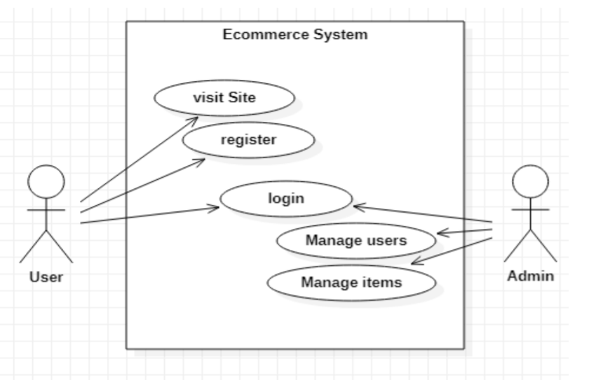

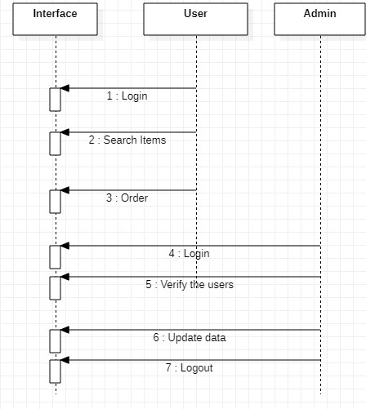
Figure: Sequence Diagram

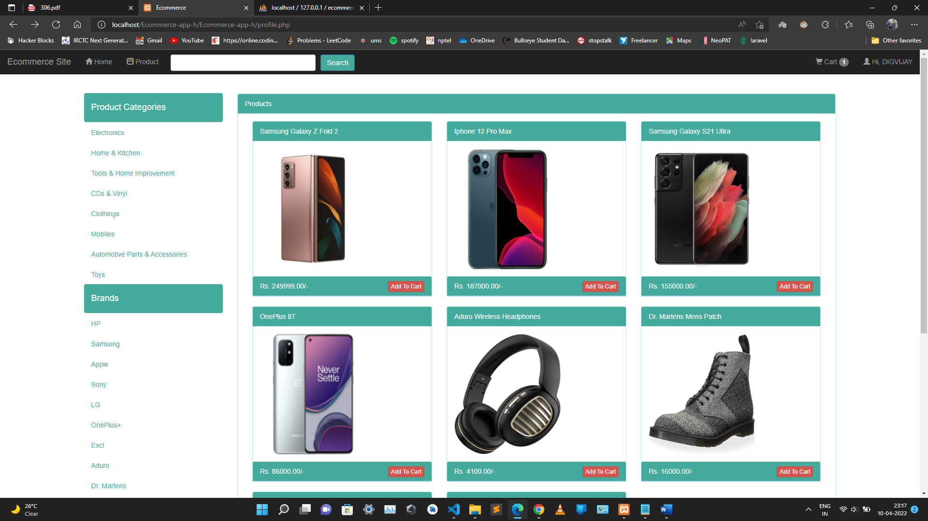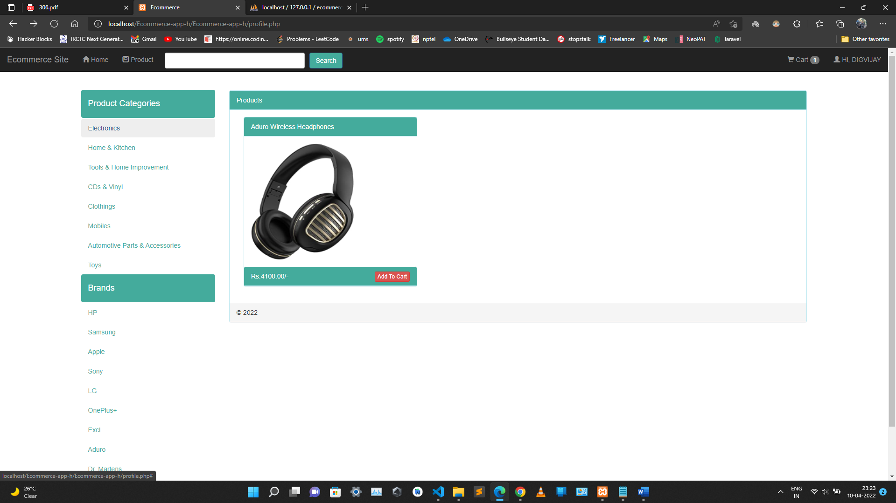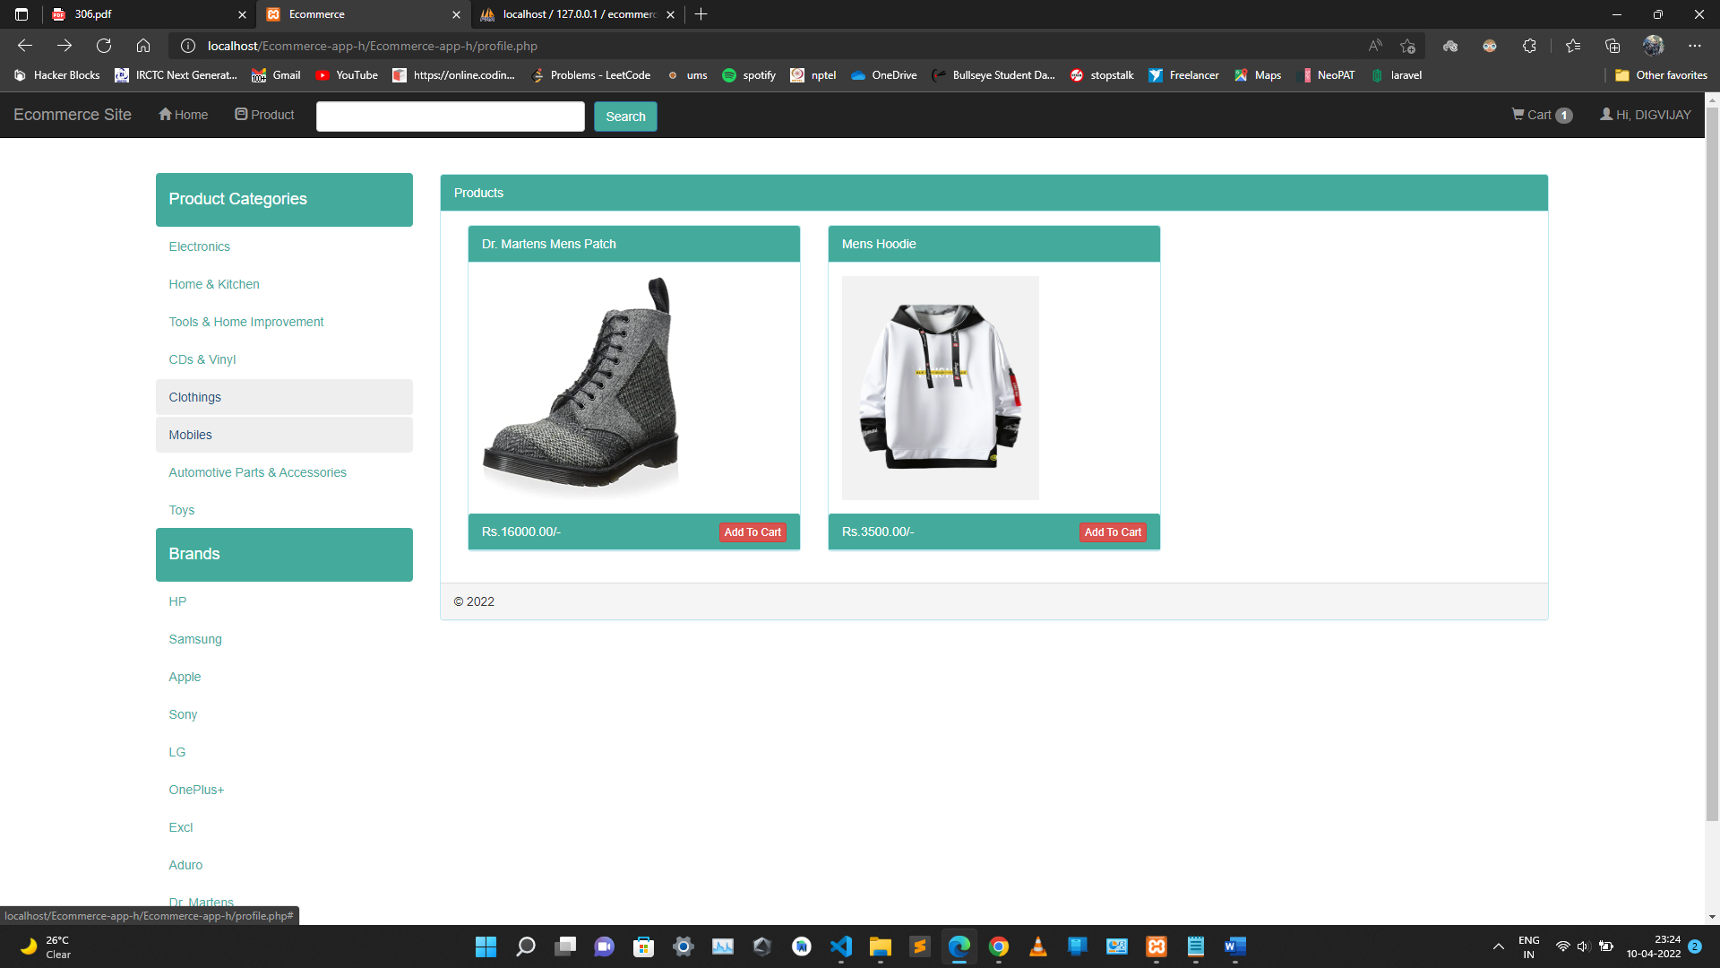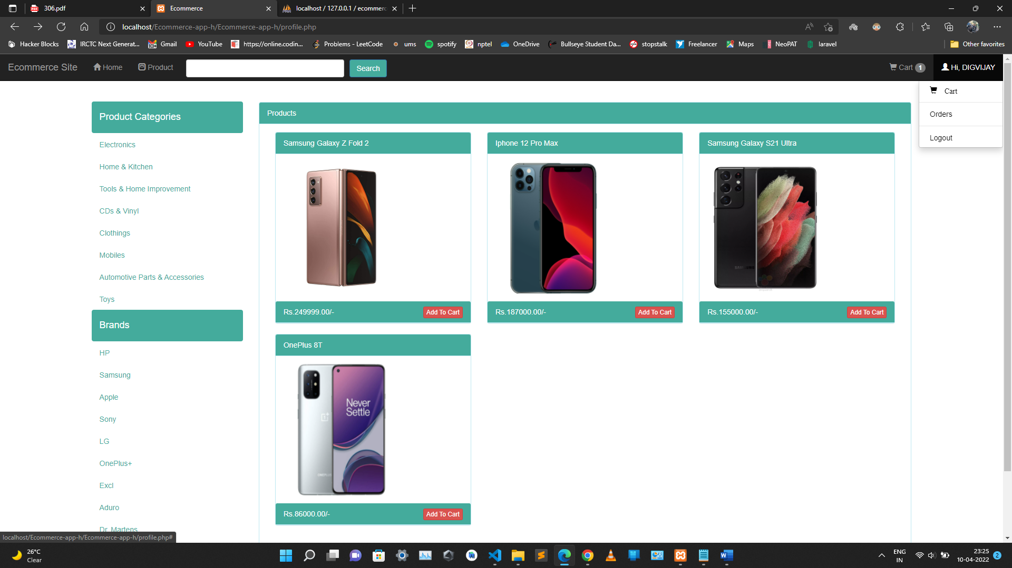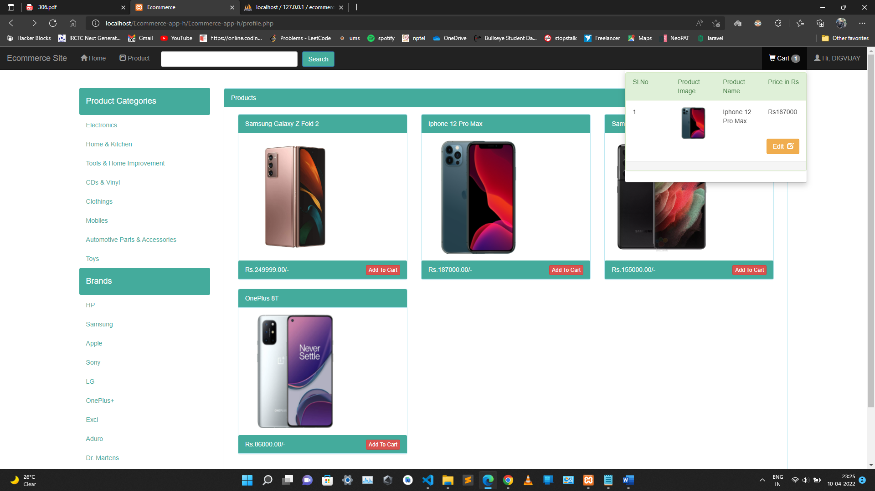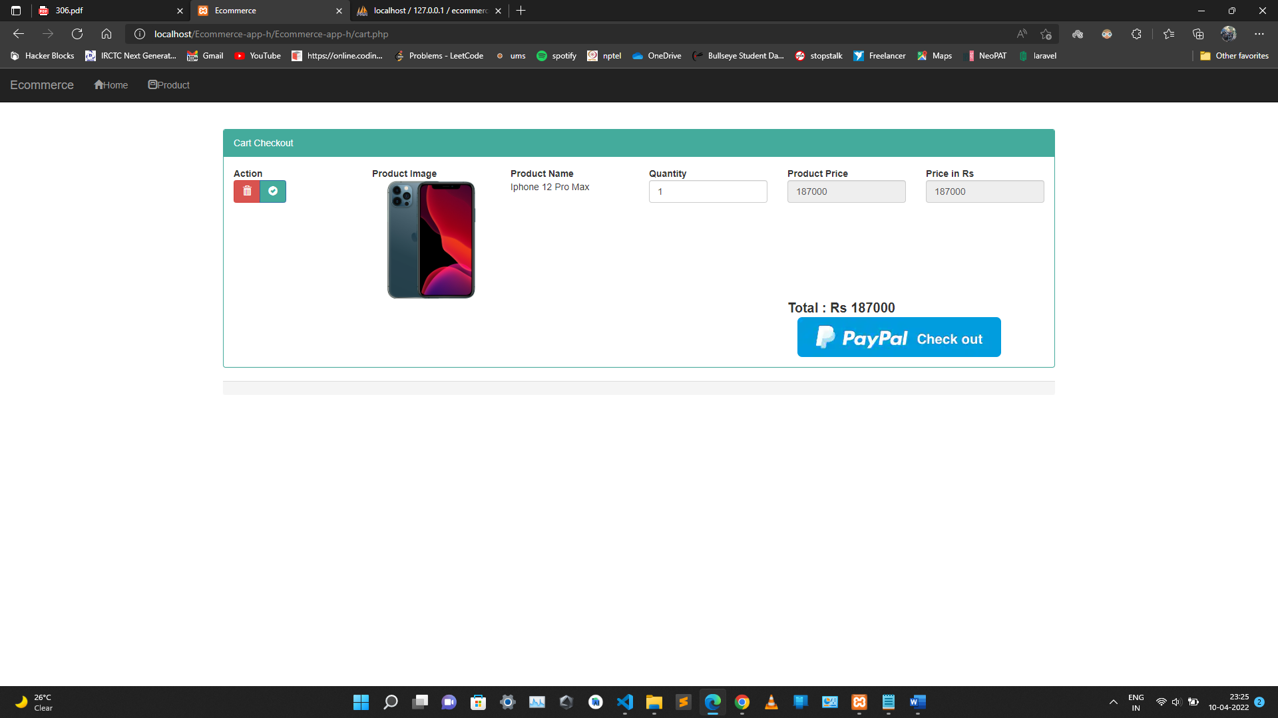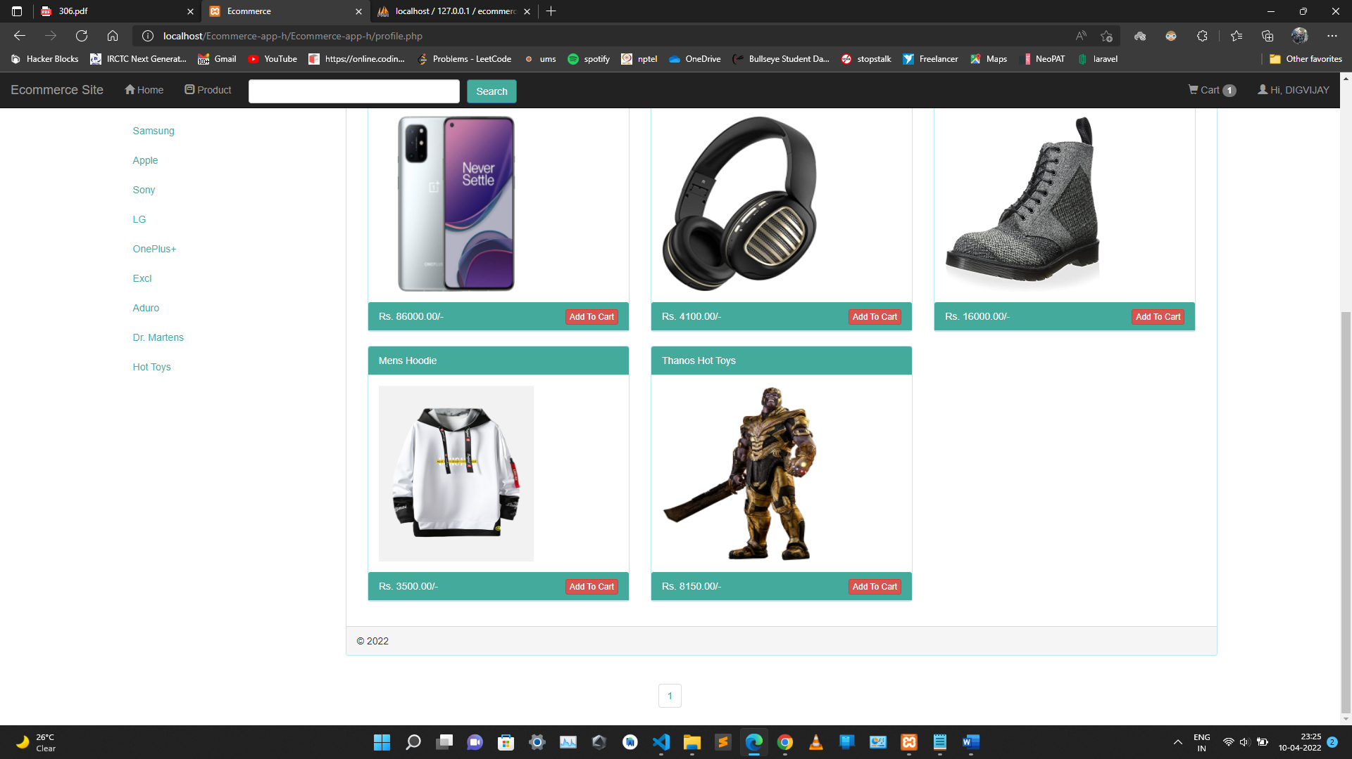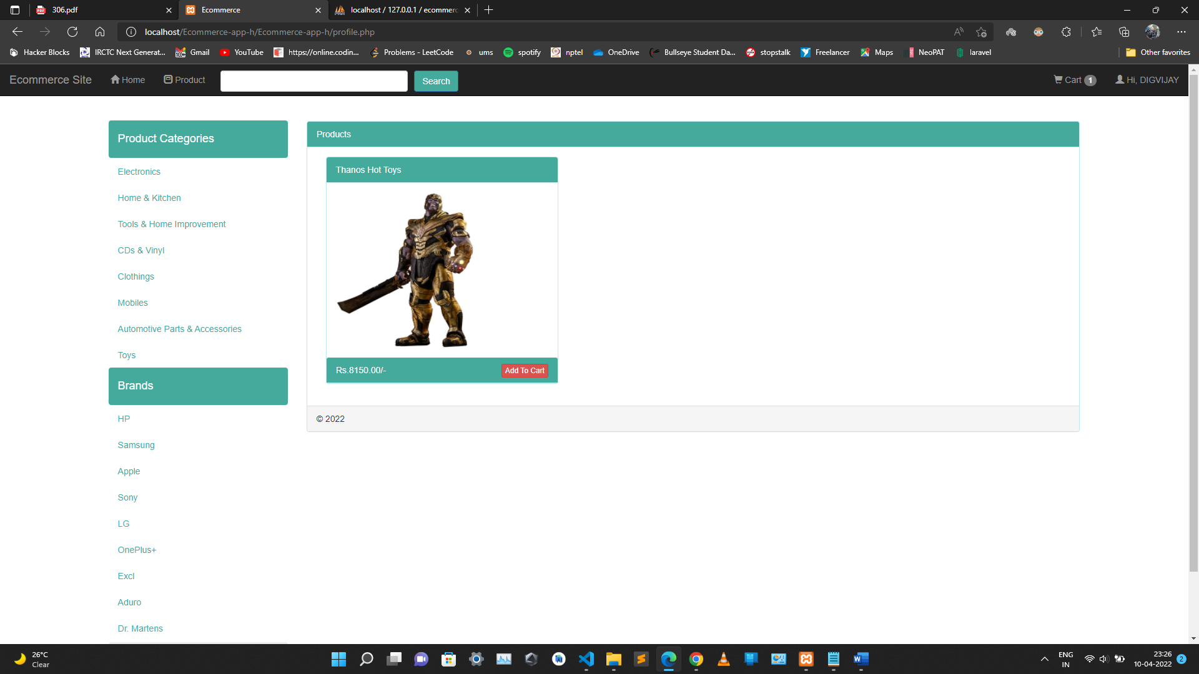

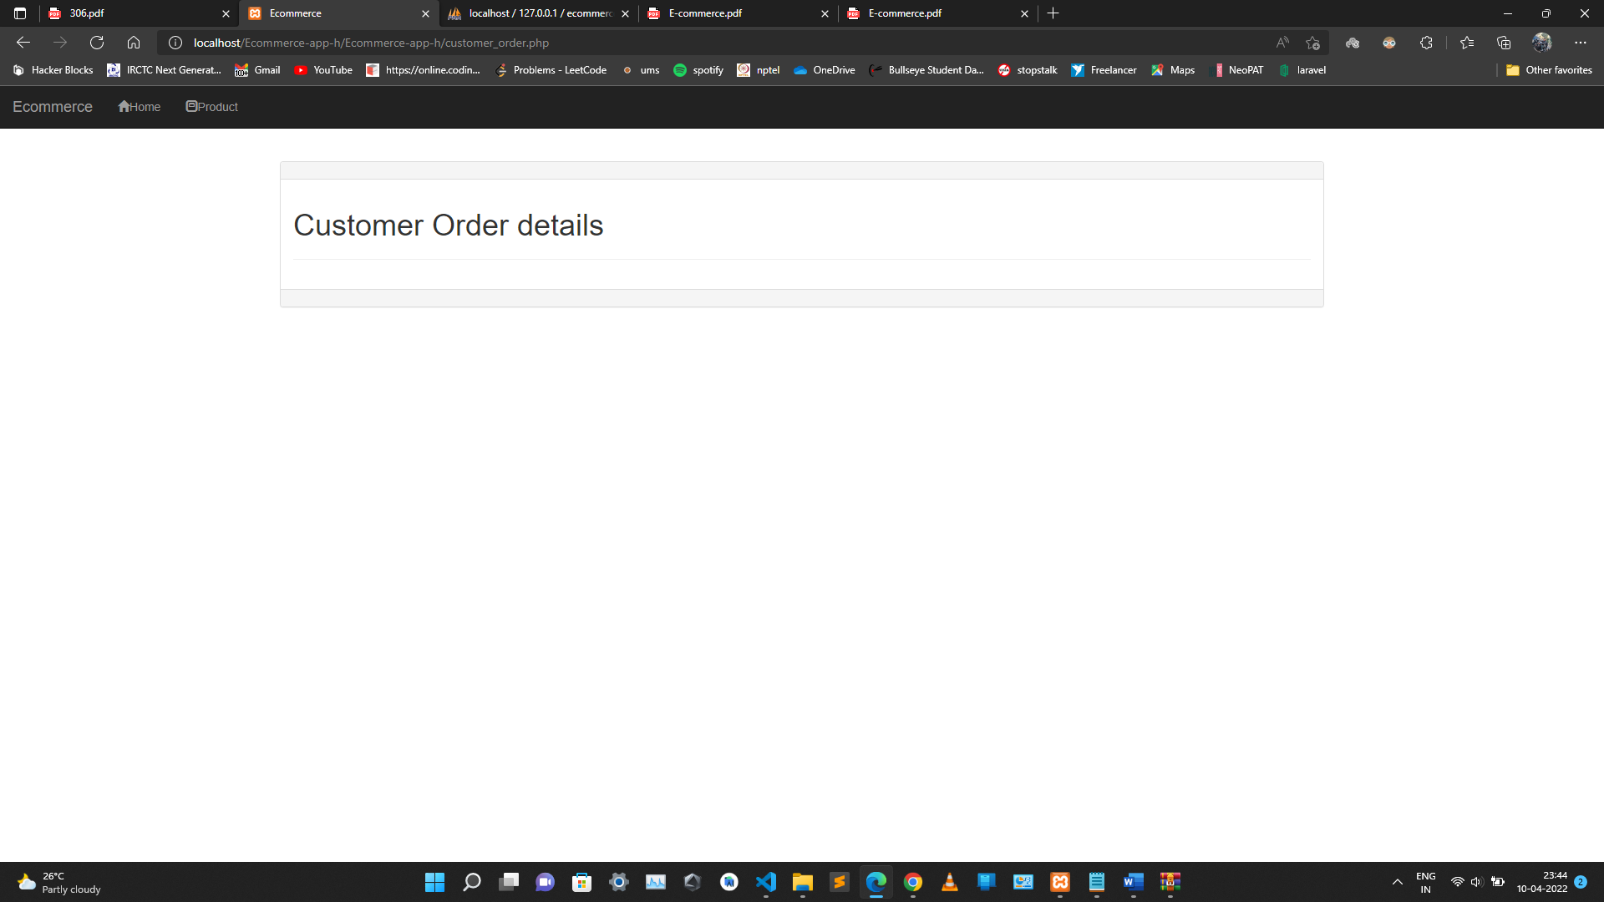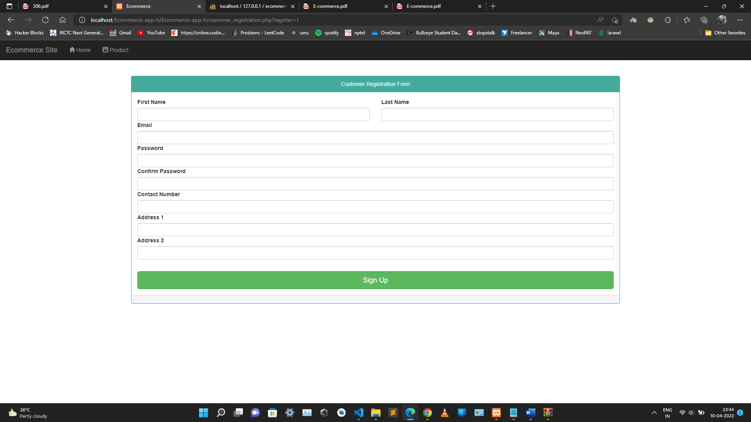

Github Link
https://github.com/psycho-codr/int220

- LEARNING FROM THE PROJECT
To conclude the description about the project : The project, developed using PHP and MySQL is based on the requirement specification of the user and the analysis of the existing system, with flexibility for future enhancement. The expanded functionality of today’s software requires an appropriate approach towards software development. This ecommerce software is designed E-commerce site project is developed using PHP, CSS, Bootstrap, and JavaScript. Talking about the project, it has all the required essential features. This project has a user side where he/she can view product category and add products to cart and proceed for checkout whereas from administration side he/she can view sales, number of product, users, daily sales report, add product and categories. The user can also leave comments on each product if he/she wants. In this project, all the main functions are performed from the Admin side.User Friendly.

